TATA TECHNOLOGIES LTD.
TECH PULSE FY-26 | AI/ML Capstone Project
PROJECT SYNOPSIS

Student Details
Institute/University: Pimpri Chinchwad College of Engineering (PCCOE), Pune
Programme / Batch: Digital Track
Student Name: Dhruv Pujari
PRN: 123B1D039
1. Case Study ID and Project Title / Topic
Case Study ID (CS1 to CS5): CS1
Project Title / Topic: AUTOSAR HLD Document Analysis Assistant (local LLM + RAG with cited answers)
2. Objectives
Objectives
- Build a locally hosted assistant where an engineer uploads an AUTOSAR High-Level Design (HLD) PDF, asks questions in plain English and gets answers along with the page and section they came from.
- Extract the architecture entities (software components, ports, interfaces, signals, dependencies) into a structured inventory that can be searched and exported as CSV / JSON.
- Run simple consistency checks on that inventory, such as an interface that is used but never defined, or a signal with a producer and no consumer, and compare two revisions of the same HLD.
- Evaluate the system using a fixed question set covering retrieval, citation accuracy, answer correctness, entity extraction, defect detection and response latency, and report both successful and failed cases.
3. Scope
In Scope
- Ingestion of PDF HLDs: text, headings, tables, page numbers and revision history, with Tesseract OCR for scanned pages.
- Section-aware chunking, BGE embeddings and a persistent ChromaDB collection per project, with document version and page stored as metadata.
- Cited question answering over the uploaded documents, with a "not found in the documents" reply when nothing relevant is retrieved.
- Component / interface / signal / dependency extraction, an inventory view with CSV and JSON export, rule-based mismatch and completeness report, and revision comparison.
- Streamlit review screen (accept / edit / reject), FastAPI backend, SQLite audit log, Docker packaging and the evaluation scripts.
Out of Scope – Will Not Be Implemented
- Real or confidential OEM / Tier-1 HLDs. Only synthetic AUTOSAR-style documents prepared by me are used.
- Automatic approval of architecture decisions or any change to the source HLD. Every finding stays "pending" until a person reviews it.
- Reading architecture diagrams as images (block / UML diagrams), ARXML or configuration generation, LLM fine-tuning, Neo4j graph store and enterprise SSO. Diagrams are listed as a known limitation.
4. Proposed Approach
Pre-trained model (name, version, local/private hosting)
Llama 3.1 8B Instruct, 4-bit quantised (Q4_K_M GGUF), served locally with Ollama. No external API is called.
Temperature 0.1, context window 8192.
Embedding model
BAAI/bge-small-en-v1.5 (384 dimensions) through sentence-transformers, runs fine on CPU.
I will compare it with bge-base-en-v1.5 on the test questions and keep whichever retrieves better.
Vector store (FAISS / ChromaDB)
ChromaDB (persistent client, cosine distance), one collection per project so documents from different projects do not mix.
Metadata kept with every chunk: document name, version label, page, section heading, chunk type (text / table). Metadata filtering is the reason for choosing Chroma over a plain FAISS index.
RAG pipeline and/or AI-agent design – brief description
Custom Python pipeline, no agent framework. PDF is parsed with PyMuPDF (pdfplumber for tables), split by heading into chunks of about 500 tokens with 80 overlap, tables kept as their own chunks, then embedded and stored.
At query time the top 5 chunks above a score threshold are retrieved and put in the prompt tagged [doc | version | page | section]. The model is told to answer only from this context, cite the tags and say "not found" otherwise. A post-check confirms that every citation points to a chunk that was actually retrieved; if not, the answer is flagged low confidence.
Service layer and UI (e.g., FastAPI / Flask / Streamlit)
FastAPI for the backend (/ingest, /query, /entities, /compare, /export, /review), Streamlit for the UI, SQLite for documents, review status and the audit log. Python 3.11.

Tools / deterministic rules, if applicable
Regex rules for AUTOSAR-style naming (component, port and Rte_Read / Rte_Write names) to cross-check what the LLM extracts, plus Pydantic schema validation of the JSON output.
Rule checks: undefined interface, signal without consumer, dependency on an unknown component, duplicate component name, and version-to-version differences. Confidence comes from retrieval score and the citation check, not from the model rating itself.
Proposed System / Architecture
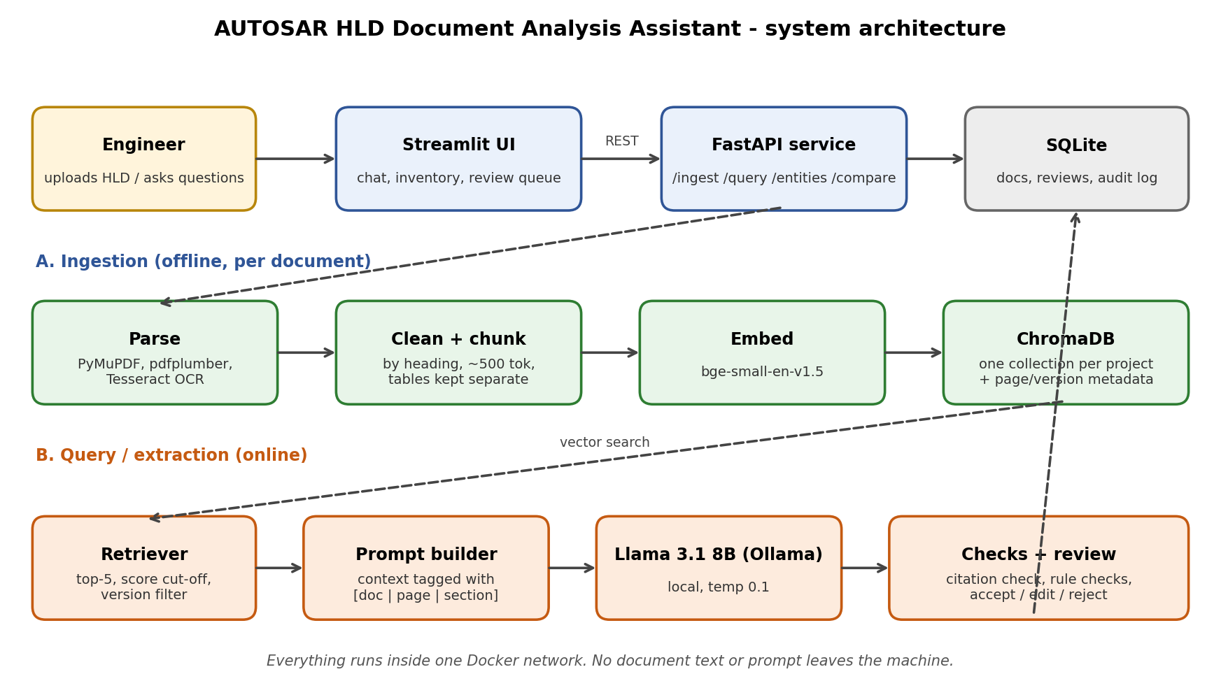
5. Input Data / Knowledge Base
Use approved or synthetic data only.
Data / Knowledge Sources
About 5 synthetic HLD PDFs written in AUTOSAR style for body-domain ECU functions (for example door lock, window lift, battery monitoring), each with component descriptions, port / interface tables, signal lists, functional flows and a revision history. One document has two revisions for the comparison feature.
A component catalogue and an interface list as CSV, plus a short glossary. About 10 defects are seeded on purpose (missing interface, orphan signal, version mismatch) so the checks can be measured.
Approximate Size and Format
Approximately 40-60 pages in total, with 5 synthetic AUTOSAR-style HLD PDFs, two CSV files (component catalogue and interface list) and a test set of 50-60 questions in CSV / JSON.

Preprocessing and EDA Planned
Check text layer per page, strip repeated headers / footers and page numbers, fix hyphenation and whitespace, and verify extracted tables by hand on a sample.
EDA: pages and tokens per document, chunk length distribution, number of tables, entity frequency counts, duplicate chunk check.
6. Expected Outcomes and Evaluation Plan
Expected Outputs – aligned to the case study
Cited answers to questions, a component and interface inventory, dependency list, short per-component summaries with page citations, a mismatch report, a revision diff and CSV / JSON export.

Evaluation Method – test question set / ground truth / metrics / validation approach
Test set of about 50 questions in four types: direct fact, table lookup, multi-section, and questions whose answer is not in the documents. Each has a ground-truth answer and page number written by me.
Metrics: retrieval hit@k, citation accuracy, answer correctness, correct "not found" rate, entity extraction precision / recall / F1, port-link extraction F1, defect recall, defect false alarms, and query latency.
Responsible AI Measures – grounding and citations / privacy / security / human oversight
Grounding: answers use retrieved text only and carry page citations; weak retrieval gives "not found". Privacy and security: all models and data stay local, synthetic data only, project-wise collections, and an audit log of queries and review decisions.
Human oversight: nothing is final until a reviewer accepts it in the review queue. Text from documents is treated as data, not instructions, to reduce prompt injection risk.
MLOps / Deployment Elements Planned – versioning / Docker / tracking
Git for code with tagged versions, pinned requirements.txt, prompts and parameters kept in YAML files under version control, Dockerfile and docker-compose (API, UI, Ollama), persistent volume for ChromaDB.
Evaluation runs are stored in the Evaluation_Results folder with configuration parameters and metric results for comparison.
7. Planned AI-Tool Usage
Mention the AI tools / models used for coding assistance and specify the purpose and project artifact affected. This information will be carried into the final AI-tool usage declaration.
AI Tool / Model
Claude (Anthropic) for coding help and drafting.
Purpose
Help with writing and debugging Python code (ingestion, API, Streamlit), drafting the synthetic HLD text and test questions for me to review and correct, and proofreading documents.
Artifact Affected
Code/, Input_Data/ (synthetic documents), Evaluation_Results/ scripts and Documentation/. Model outputs and evaluation numbers are produced by running my own system.
Student Declaration
☑ I will not change the approved case-study scope, major methodology, or implementation approach without prior faculty approval.
☑ I confirm that the work submitted under this synopsis represents my own understanding and contribution, and I will be responsible for explaining every significant part of the selected case study and its implementation.

Name and Signature: Dhruv Pujari  Date: 07/10/2026

